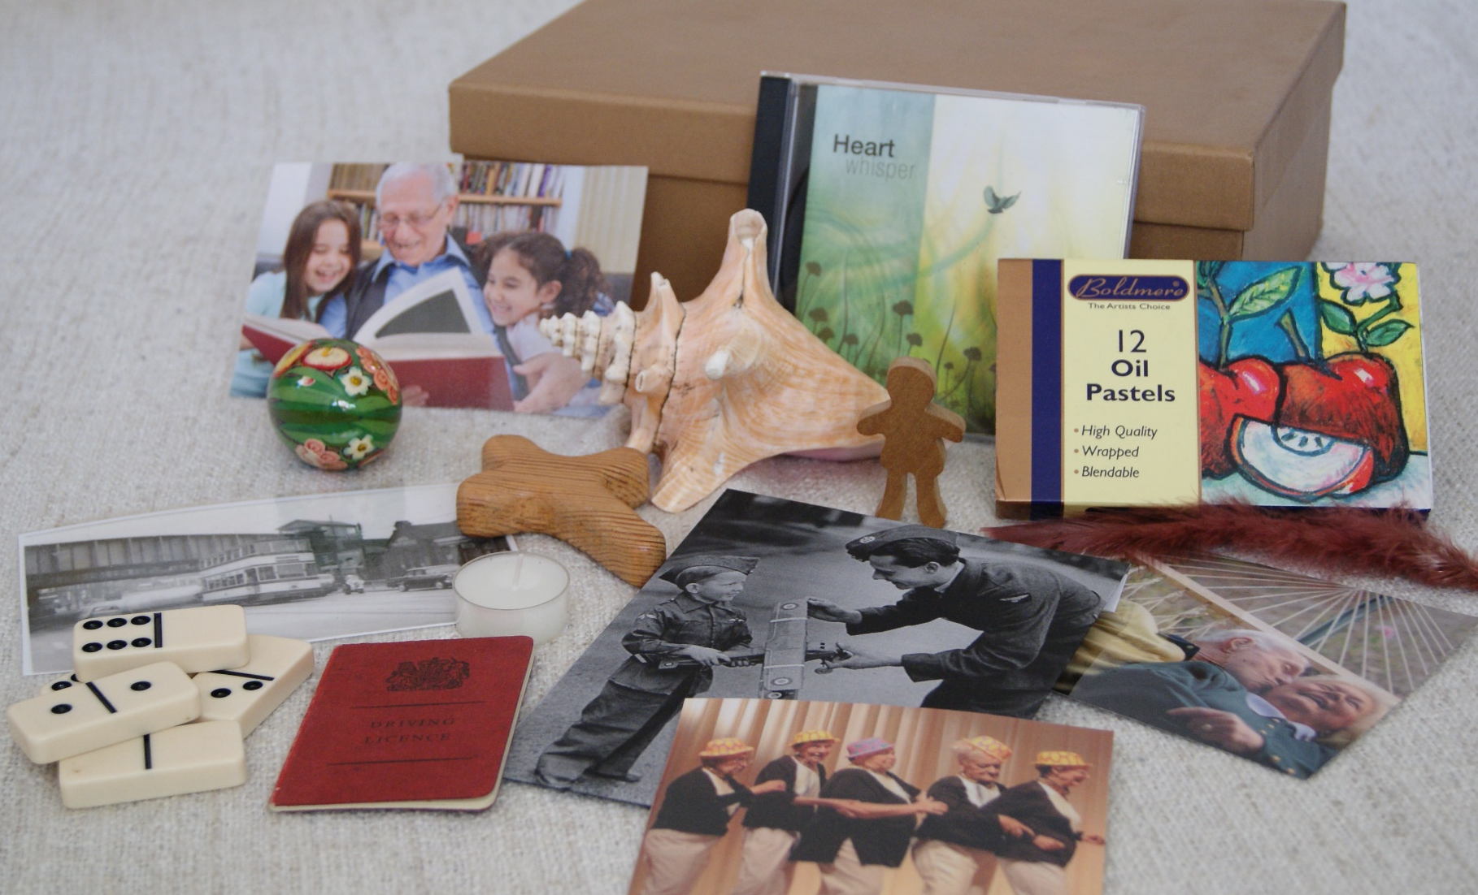

How to Make a Gold Box
Materials
- Paintbrushes (large and medium wall brushes)
- Gold Paint We suggest Johnstone's Revive Metallic furniture gold paint or Craig and Rose gold metallic paint
- A large A4 cardboard file box with removable lid. We suggest Hobby Craft or Home Bargins
- Newspaper
- Water
Instructions
- Give the box one coat of paint (thin down the paint with a drop of water if necessary)
- Leave to dry for one hour
- Give a second coat

